Лабораторна робота № 6

Удосконалення програм емулятора дисплейного модуля і клієнта.

Студента групи КН-21-1

Новгородського О.О.

Етапи виконання лабораторної роботи:

1. Розширити специфікацію протоколу обміну даними для підтримки просунутого набору команд :

set orientation: orientation //(0=0, 1=90, 2=180, 3=270)

get width:

get height:

2. Внести виправлення в код емулятора дисплейного модуля для підтримки нових команд (див. п1).

3. Внести виправлення в код реалізації інтерфейсу клієнта GrpahicsLib.h для підтримки нових команд (див. п1).

4. Опис попередніх команд в специфікації не міняти.

**Лістинг програми(Client):**

unit Maim;

interface

uses

System.SysUtils, System.Types, System.UITypes, System.Classes, System.Variants,

FMX.Types, FMX.Controls, FMX.Forms, FMX.Graphics, FMX.Dialogs,

FMX.Controls.Presentation, FMX.StdCtrls, IdBaseComponent, IdComponent,

IdUDPBase, IdUDPClient, FMX.Memo.Types, FMX.ScrollBox, FMX.Memo, System.DateUtils, idGlobal,

FMX.Edit, FMX.ComboEdit, FMX.Objects, IdUDPServer, IdSocketHandle;

type TPacket = packed record

msLen:Byte;

colorarray:array [1..40,1..40] of cardinal;

w:integer;

h:integer;

msg:string[255];

end;

const commands: array [1..11] of string = (

'drawline', 'drawellipse', 'drawtext', 'clear', 'drawimage','fillroundedrectangle','drawpixel','drawsymbol','setorientation','getwidth','getheight'

);

// Перечисление для типов команд

type TCommand=(DRAW_LINE, DRAW_ELLIPSE, DRAW_TEXT, CLEAR, DRAW_IMAGE, FILL_ROUNDED_RECTANGLE, DRAW_PIXEL, DRAW_SYMBOL, SET_ORIENTATION, GET_WIDTH, GET_HEIGHT);

type

TForm1 = class(TForm)

IdUDPClient1: TIdUDPClient;

Button1: TButton;

Memo1: TMemo;

ComboEdit1: TComboEdit;

Label1: TLabel;

Image1: TImage;

IdUDPServer1: TIdUDPServer;

procedure Button1Click(Sender: TObject);

procedure IdUDPServer1UDPRead(AThread: TIdUDPListenerThread;

const AData: TIdBytes; ABinding: TIdSocketHandle);

procedure FormCreate(Sender: TObject);

private

{ Private declarations }

bmp:TBitmap;

packet:TPacket;

send_data:TIdBytes;

sendcommand:TCommand;

public

{ Public declarations }

function DrawPixelEncode(const sendcommand, px1,py1,parcolor:string):string;

function SetOrientationEncode(const sendcommand, deg:string):string;

function GetWidthEncode(const sendcommand:string):string;

function GetHeightEncode(const sendcommand:string):string;

function DrawLineEncode(const sendcommand, parx1,pary1,parx2,pary2,parcolor:string):string;

function DrawSymbolEncode(const sendcommand, symbol, x,y,parcolor:string):string;

function DrawEllipseEncode(const sendcommand, elx1,ely1,elx2,ely2,parcolor:string):string;

function DrawTextEncode(const sendcommand, tx1,ty1,tx2,ty2,text,parcolor:string):string;

function ClearEncode(const sendcommand:string; const parcolor:string):string;

function DrawImageEncode(const sendcommand:string; width,heigth:string):string;

function FillRoundedRectangleEncode(const sendcommand:string; px1,py1,px2,py2,radius,parcolor:string):string;

end;

var

Form1: TForm1;

implementation

{$R *.fmx}

procedure TForm1.Button1Click(Sender: TObject);

var spl:TArray<string>; s:string; i:integer; iw,jw:integer; b:TBitmapData;

begin

packet.msLen:=Length(Memo1.Text);

SetLength(packet.msg,packet.msLen);

s:=Memo1.Text;

spl:=s.Split([' ']);

for i:=1 to 11 do

begin

if commands[i]=spl[0] then

begin

sendcommand:=TCommand(i-1);

case sendcommand of

TCommand.DRAW_LINE:

packet.msg:=DrawLineEncode((i-1).ToString,spl[1],spl[2],spl[3],spl[4],spl[5]);

TCommand.DRAW_ELLIPSE:

packet.msg:=DrawEllipseEncode((i-1).ToString,spl[1],spl[2],spl[3],spl[4],spl[5]);

TCommand.DRAW_TEXT:

packet.msg:=DrawTextEncode((i-1).ToString,spl[1],spl[2],spl[3],spl[4],spl[5],spl[6]);

TCommand.CLEAR:

packet.msg:=ClearEncode((i-1).ToString,spl[1]);

TCommand.DRAW_IMAGE:

begin

packet.msg:=DrawImageEncode((i-1).ToString,spl[1],spl[2]);

bmp:=TBitmap.CreateFromFile(spl[3]);

packet.w:=bmp.Width;

packet.h:=bmp.Height;

bmp.Map(TMapAccess.Read,b);

for iw:=1 to Round(bmp.Width) do

for jw:=1 to Round(bmp.Height) do

packet.colorarray[iw,jw]:=b.GetPixel(iw,jw);

bmp.Unmap(b);

Image1.Bitmap.Assign(bmp);

end;

TCommand.FILL_ROUNDED_RECTANGLE:

begin

packet.msg:=FillRoundedRectangleEncode((i-1).ToString,spl[1],spl[2],spl[3],spl[4],spl[5],spl[6]);

end;

TCommand.DRAW_PIXEL:

begin

packet.msg:=DrawPixelEncode((i-1).ToString,spl[1],spl[2],spl[3]);

end;

TCommand.DRAW_SYMBOL:

begin

packet.msg:=DrawSymbolEncode((i-1).ToString,spl[1],spl[2],spl[3],spl[4]);

end;

TCommand.SET_ORIENTATION:

begin

packet.msg:=SetOrientationEncode((i-1).ToString,spl[1]);

end;

TCommand.GET_WIDTH:

begin

packet.msg:=GetWidthEncode((i-1).ToString);

end;

TCommand.GET_HEIGHT:

begin

packet.msg:=GetHeightEncode((i-1).ToString);

end;

end;

end;

end;

IdUDPClient1.Active:=true;

IdUDPClient1.Port:=5000;

IdUDPClient1.Host:=ComboEdit1.Text;

IdUDPClient1.Connect;

if IdUDPClient1.Connected then

begin

SetLength(send_data,sizeof(packet));

Move(packet,send_data[0],sizeof(packet));

IdUDPClient1.SendBuffer(send_data);

end;

IdUDPClient1.Active:=false;

end;

function TForm1.ClearEncode(const sendcommand:string; const parcolor: string): string;

var command:integer;

begin

try

command:=Integer.Parse(sendcommand);

Result:=command.ToString+' '+parcolor;

except on EConvertError do

begin

ShowMessage('Цвет неверный!!!');

Result:='3 '+'000000';

end;

end;

end;

function TForm1.DrawSymbolEncode(const sendcommand, symbol, x, y, parcolor: string): string;

var xx,yy: Double; command:integer;

begin

try

xx:=Double.Parse(x);

yy:=Double.Parse(y);

command:=Integer.Parse(sendcommand);

Result:=command.ToString+' '+symbol+' '+xx.ToString+' '+yy.ToString+' '+parcolor;

except on EConvertError do

begin

ShowMessage('Координаты буквы неверны!!!');

Result:='7 0 0 0 0';

end;

end;

end;

function TForm1.DrawEllipseEncode(const sendcommand, elx1, ely1, elx2, ely2,

parcolor: string): string;

var x1,y1,x2,y2,command:integer;

begin

try

x1:=Integer.Parse(elx1);

y1:=Integer.Parse(ely1);

x2:=Integer.Parse(elx2);

y2:=Integer.Parse(ely2);

command:=Integer.Parse(sendcommand);

Result:=command.ToString+' '+x1.ToString+' '+y1.ToString+' '+x2.ToString+' '+y2.ToString+' '+parcolor;

except on EConvertError do

begin

ShowMessage('Координаты эллипса неверны!!!');

Result:='1 0 0 0 0 '+parcolor;

end;

end;

end;

function TForm1.DrawImageEncode(const sendcommand: string; width,

heigth: string): string;

var w,h,command:integer;

begin

try

w:=Integer.Parse(width);

h:=Integer.Parse(heigth);

command:=Integer.Parse(sendcommand);

Result:=command.ToString+' '+w.ToString+' '+h.ToString;

except on EConvertError do

begin

ShowMessage('размеры неверны!!!');

Result:='4 0 0';

end;

end;

end;

function TForm1.DrawLineEncode(const sendcommand, parx1, pary1, parx2, pary2,

parcolor: string): string;

var x1,y1,x2,y2,command:integer;

begin

try

x1:=Integer.Parse(parx1);

y1:=Integer.Parse(pary1);

x2:=Integer.Parse(parx2);

y2:=Integer.Parse(pary2);

command:=Integer.Parse(sendcommand);

Result:=command.ToString+' '+x1.ToString+' '+y1.ToString+' '+x2.ToString+' '

+y2.ToString+' '+parcolor;

except on EConvertError do

begin

ShowMessage('Координаты линии неверны!!!');

Result:='0 0 0 0 0 '+parcolor;

end;

end;

end;

function TForm1.DrawPixelEncode(const sendcommand, px1, py1,

parcolor: string): string;

var x1,y1,command:integer;

begin

try

x1:=Integer.Parse(px1);

y1:=Integer.Parse(py1);

command:=Integer.Parse(sendcommand);

Result:=command.ToString+' '+x1.ToString+' '+y1.ToString+' '+parcolor;

except on EConvertError do

begin

ShowMessage('Координаты линии неверны!!!');

Result:='6 0 0 '+parcolor;

end;

end;

end;

function TForm1.DrawTextEncode(const sendcommand, tx1, ty1, tx2, ty2, text,

parcolor: string): string;

var x1,y1,x2,y2,command:integer;

begin

try

x1:=Integer.Parse(tx1);

y1:=Integer.Parse(ty1);

x2:=Integer.Parse(tx2);

y2:=Integer.Parse(ty2);

command:=Integer.Parse(sendcommand);

Result:=command.ToString+' '+x1.ToString+' '+y1.ToString+' '+x2.ToString+' '

+y2.ToString+' '+text+' '+parcolor;

except on EConvertError do

begin

ShowMessage('Координаты линии неверны!!!');

Result:='2 0 0 0 0 '+text+' '+parcolor;

end;

end;

end;

function TForm1.FillRoundedRectangleEncode(const sendcommand: string; px1, py1,

px2, py2, radius, parcolor: string): string;

var x1,y1,x2,y2,rad,command,color:integer;

begin

try

x1:=Integer.Parse(px1);

y1:=Integer.Parse(py1);

x2:=Integer.Parse(px2);

y2:=Integer.Parse(py2);

rad:=Integer.Parse(radius);

command:=Integer.Parse(sendcommand);

Result:=command.ToString+' '+x1.ToString+' '+y1.ToString+' '+

x2.ToString+' '+y2.ToString+' '+rad.ToString+' '+parcolor;

except on EConvertError do

begin

ShowMessage('Ошибка!!!');

Result:='5 0 0 0 0 0 0';

end;

end;

end;

procedure TForm1.FormCreate(Sender: TObject);

begin

IdUDPServer1.Active:=True;

end;

function TForm1.GetHeightEncode(const sendcommand: string): string;

var command:integer;

begin

try

Result:=command.ToString;

except on EConvertError do

begin

ShowMessage('Ошибка!!!');

Result:='10 0';

end;

end;

end;

function TForm1.GetWidthEncode(const sendcommand: string): string;

var command:integer;

begin

try

Result:=command.ToString;

except on EConvertError do

begin

ShowMessage('Ошибка!!!');

Result:='9 0';

end;

end;

end;

procedure TForm1.IdUDPServer1UDPRead(AThread: TIdUDPListenerThread;

const AData: TIdBytes; ABinding: TIdSocketHandle);

var i:integer; s:string; spl:TArray<string>;

begin

s:='';

try

i:=0;

while(AData[i]<>0) do

begin

s:=s+Chr(AData[i]);

i:=i+1;

end;

finally

Memo1.Lines.Clear;

Memo1.Lines.Add(s);

end;

end;

function TForm1.SetOrientationEncode(const sendcommand, deg: string): string;

var command,degrees:integer;

begin

try

degrees:=Integer.Parse(deg);

command:=Integer.Parse(sendcommand);

Result:=command.ToString+' '+degrees.ToString;

except on EConvertError do

begin

ShowMessage('Ошибка!!!');

Result:='8 0';

end;

end;

end;

end.

**Лістинг програми(Server):**

unit Main;

interface

uses

System.SysUtils, System.Types, System.UITypes, System.Classes, System.Variants,

FMX.Types, FMX.Controls, FMX.Forms, FMX.Graphics, FMX.Dialogs,

FMX.Controls.Presentation, FMX.StdCtrls, IdBaseComponent, IdComponent,

IdUDPBase, IdUDPServer, IdGlobal, IdSocketHandle, FMX.Memo.Types,

FMX.ScrollBox, FMX.Memo, System.DateUtils, FMX.Objects, MyCommands, System.Generics.Collections,

IdUDPClient, FMX.Edit;

const symbols: array [1..8] of string = (

'A', 'B', 'C', 'D', 'E', 'F', 'G', 'H'

);

// Запись для приема данных от клиента

type TPacket = packed record

msLen:Byte;

colorarray:array [1..40,1..40] of cardinal;

w:integer;

h:integer;

msg:string[255];

end;

// Параметры картинки

type TPicData = class

pic:TBitmap;

x:Double;

y:Double;

constructor Create(var x,y:Double;var pic:TBitmap); overload;

end;

// Параметры надписи

type TTextData = class

text:string;

x1:Double;

y1:Double;

x2:Double;

y2:Double;

color:string;

constructor Create(var text:string; var x1,y1,x2,y2:Double; color:string); overload;

end;

type TEllipseData = class

x1:Double;

y1:Double;

x2:Double;

y2:Double;

color:string;

constructor Create(var x1,y1,x2,y2:Double; color:string); overload;

end;

type TPixelData = class

x1:Double;

y1:Double;

color:string;

constructor Create(var x1,y1:Double; color:string); overload;

end;

type TSymbolData = class

x:Double;

y:Double;

color:string;

symbpos:integer;

constructor Create(var x, y : Double; color : string; symbpos : integer); overload;

end;

type TFillRoundedRectangleData = class

x1:Integer;

y1:Integer;

x2:Integer;

y2:Integer;

radius:Integer;

color:string;

constructor Create(var x1,y1,x2,y2,radius:Integer;color:string); overload;

end;

// Параметры линии

type TLineData = class

p1:TPointF;

p2:TPointF;

color:string;

constructor Create(var p1,p2:TPointF; color:string); overload;

end;

// Перечисление для типов команд

type TCommand=(DRAW_LINE, DRAW_ELLIPSE, DRAW_TEXT, CLEAR, DRAW_IMAGE, FILL_ROUNDED_RECTANGLE, DRAW_PIXEL, DRAW_SYMBOL, SET_ORIENTATION, GET_WIDTH, GET_HEIGHT);

type

TForm1 = class(TForm)

IdUDPServer1: TIdUDPServer;

ToolBar1: TToolBar;

Label2: TLabel;

PaintBox1: TPaintBox;

IdUDPClient1: TIdUDPClient;

Edit1: TEdit;

procedure FormCreate(Sender: TObject);

procedure IdUDPServer1UDPRead(AThread: TIdUDPListenerThread;

const AData: TIdBytes; ABinding: TIdSocketHandle);

procedure PaintBox1Paint(Sender: TObject; Canvas: TCanvas);

private

{ Private declarations }

bmp:TBitmap;

packet:TPacket;

command:TCommand;

drawcommand:integer;

piclist:TList<TPicData>;

textlist:TList<TTextData>;

linelist:TList<TLineData>;

ellipselist:TList<TEllipseData>;

fillroundedrectanglelist:TList<TFillRoundedRectangleData>;

pixellist:TList<TPixelData>;

symbollist:TList<TSymbolData>;

public

{ Public declarations }

end;

var

Form1: TForm1;

implementation

{$R *.fmx}

procedure TForm1.FormCreate(Sender: TObject);

begin

IdUDPServer1.Active:=true;

TMyCommands.linepath:=TPathData.Create;

TMyCommands.ellipsepath:=TPathData.Create;

TMyCommands.clearcolor:='000000';

piclist:=TList<TPicData>.Create;

textlist:=TList<TTextData>.Create;

linelist:=TList<TLineData>.Create;

ellipselist:=TList<TEllipseData>.Create;

fillroundedrectanglelist:=TList<TFillRoundedRectangleData>.Create;

pixellist:=TList<TPixelData>.Create;

symbollist:=TList<TSymbolData>.Create;

end;

procedure TForm1.IdUDPServer1UDPRead(AThread: TIdUDPListenerThread;

const AData: TIdBytes; ABinding: TIdSocketHandle);

var s:string; i:integer; spl:TArray<string>; iw,jw:integer;

b1:TBitmapData; picdata:TPicData; textdata:TTextData;

linedata:TLineData; ellipsedata:TEllipseData;

fillroundedrectangledata:TFillRoundedRectangleData;

pixeldata:TPixelData; px,py:Double; mysymboldata:TSymbolData;

symbolpos:integer; symbolx,symboly:Double; symbolcolor:string;

begin

Move(AData[0],packet,sizeof(packet));

s:=packet.msg;

spl:=s.Split([' ']);

// Парсим полученную команду от клиента

command:=TCommand(Integer.Parse(spl[0]));

case command of

TCommand.DRAW_LINE:

begin

drawcommand:=Integer.Parse(spl[0]);

TMyCommands.PrepareLine(spl[1],spl[2],spl[3],spl[4],spl[5]);

linedata:=TLineData.Create(TMyCommands.p1,TMyCommands.p2,TMyCommands.linecolor);

linelist.Add(linedata);

PaintBox1.Repaint;

end;

TCommand.DRAW_ELLIPSE:

begin

drawcommand:=Integer.Parse(spl[0]);

TMyCommands.PrepareEllipse(spl[1],spl[2],spl[3],spl[4],spl[5]);

ellipsedata:=TEllipseData.Create(TMyCommands.x1_ellipse,TMyCommands.y1_ellipse,

TMyCommands.x2_ellipse,TMyCommands.y2_ellipse,TMyCommands.ellipsecolor);

ellipselist.Add(ellipsedata);

PaintBox1.Repaint;

end;

TCommand.DRAW_TEXT:

begin

drawcommand:=Integer.Parse(spl[0]);

TMyCommands.PrepareText(spl[1],spl[2],spl[3],spl[4],spl[5],spl[6]);

textdata:=TTextData.Create(TMyCommands.textout,TMyCommands.x1_text,TMyCommands.y1_text,

TMyCommands.x2_text,TMyCommands.y2_text,TMyCommands.textcolor);

textlist.Add(textdata);

PaintBox1.Repaint;

end;

TCommand.CLEAR:

begin

drawcommand:=Integer.Parse(spl[0]);

TMyCommands.PrepareClear(spl[1]);

piclist.Clear;

textlist.Clear;

linelist.Clear;

pixellist.Clear;

symbollist.Clear;

ellipselist.Clear;

fillroundedrectanglelist.Clear;

Form1.Fill.Color:=StrToInt('$ff'+TMyCommands.clearcolor);

PaintBox1.Repaint;

end;

TCommand.DRAW_IMAGE:

begin

drawcommand:=Integer.Parse(spl[0]);

TMyCommands.PrepareDrawImage(spl[1],spl[2]);

bmp:=TBitmap.Create();

bmp.SetSize(packet.w,packet.h);

bmp.Map(TMapAccess.Write,b1);

for iw:=1 to Round(bmp.Width) do

for jw:=1 to Round(bmp.Height) do

begin

b1.SetPixel(iw,jw,packet.colorarray[iw,jw]);

end;

bmp.Unmap(b1);

picdata:=TPicData.Create(TMyCommands.ximage,TMyCommands.yimage,bmp);

piclist.Add(picdata);

PaintBox1.Repaint;

end;

TCommand.FILL_ROUNDED_RECTANGLE:

begin

TMyCommands.PrepareFillRoundedRectangle(spl[1],spl[2],spl[3],spl[4],spl[5],spl[6]);

fillroundedrectangledata:=TFillRoundedRectangleData.Create(TMyCommands.x1,TMyCommands.y1,

TMyCommands.x2,TMyCommands.y2,TMyCommands.radius,TMyCommands.fillroundedrectanglecolor);

fillroundedrectanglelist.Add(fillroundedrectangledata);

PaintBox1.Repaint;

end;

TCommand.DRAW_PIXEL:

begin

TMyCommands.PreparePixel(spl[1],spl[2],spl[3]);

px:=TMyCommands.ppoint.X;

py:=TMyCommands.ppoint.Y;

pixeldata:=TPixelData.Create(px, py, TMyCommands.pixelcolor);

pixellist.Add(pixeldata);

PaintBox1.Repaint;

end;

TCommand.DRAW_SYMBOL:

begin

TMyCommands.PrepareSymbol(spl[1],spl[2],spl[3],spl[4]);

for symbolpos:=1 to 8 do

begin

if TMyCommands.symbol=symbols[symbolpos] then

begin

symbolx:=TMyCommands.sx;

symboly:=TMyCommands.sy;

symbolcolor:=TMyCommands.symbolcolor;

mysymboldata:=TSymbolData.Create(symbolx, symboly, symbolcolor, (symbolpos-1));

symbollist.Add(mysymboldata);

end;

end;

PaintBox1.Repaint;

end;

TCommand.SET_ORIENTATION:

begin

TMyCommands.PrepareOrientation(spl[1]);

PaintBox1.RotationAngle:=TMyCommands.degrees;

end;

TCommand.GET_WIDTH:

begin

IdUDPClient1.Active:=true;

IdUDPClient1.Port:=5001;

IdUDPClient1.Host:=Edit1.Text;

IdUDPClient1.Connect;

if IdUDPClient1.Connected then

begin

IdUDPClient1.Send('Canvas width: '+PaintBox1.Width.ToString);

end;

IdUDPClient1.Active:=false;

end;

TCommand.GET_HEIGHT:

begin

IdUDPClient1.Active:=true;

IdUDPClient1.Port:=5001;

IdUDPClient1.Host:=Edit1.Text;

IdUDPClient1.Connect;

if IdUDPClient1.Connected then

begin

IdUDPClient1.Send('Canvas height: '+PaintBox1.Height.ToString);

end;

IdUDPClient1.Active:=false;

end;

end;

end;

procedure TForm1.PaintBox1Paint(Sender: TObject; Canvas: TCanvas);

var i:integer; p:TPicData; t:TTextData; l:TLineData; e:TEllipseData;

frr:TFillRoundedRectangleData; pixel:TPixelData; a:TSymbolData;

begin

PaintBox1.Canvas.BeginScene();

for l in linelist do

TMyCommands.DrawMyLine(l.p1,l.p2,Canvas,StrToInt('$ff'+l.color));

for e in ellipselist do

TMyCommands.DrawMyEllipse(e.x1,e.y1,e.x2,e.y2,Canvas,StrToInt('$ff'+e.color));

for t in textlist do

TMyCommands.DrawMyText(t.x1,t.y1,t.x2,t.y2,

t.text, 30, Canvas, StrToInt('$ff'+t.color));

for p in piclist do

TMyCommands.DrawImage(p.x,p.y,p.pic,Canvas);

for frr in fillroundedrectanglelist do

TMyCommands.FillRoundedRectangle(frr.x1,frr.y1,frr.x2,frr.y2,frr.radius,

Canvas,StrToInt('$ff'+frr.color));

for pixel in pixellist do

begin

TMyCommands.DrawMyPixel(TPointF.Create(pixel.x1,pixel.y1),

Canvas,StrToInt('$ff'+pixel.color));

end;

for a in symbollist do

begin

TMyCommands.DrawSymbol(a.symbpos,TPointF.Create(a.x,a.y),Canvas,StrToInt('$ff'+a.color));

end;

PaintBox1.Canvas.EndScene;

end;

{ TPicData }

constructor TPicData.Create(var x, y: Double; var pic: TBitmap);

begin

Self.x:=x;

Self.y:=y;

Self.pic:=pic;

end;

{ TTextData }

constructor TTextData.Create(var text:string; var x1,y1,x2,y2:Double; color:string);

begin

Self.text:=text;

Self.x1:=x1;

Self.y1:=y1;

Self.x2:=x2;

Self.y2:=y2;

Self.color:=color;

end;

{ TLineData }

constructor TLineData.Create(var p1,p2:TPointF; color:string);

begin

Self.p1:=p1;

Self.p2:=p2;

Self.color:=color;

end;

{ TEllipseData }

constructor TEllipseData.Create(var x1, y1, x2, y2: Double; color: string);

begin

Self.x1:=x1;

Self.y1:=y1;

Self.x2:=x2;

Self.y2:=y2;

Self.color:=color;

end;

{ TFillRoundedRectangleData }

constructor TFillRoundedRectangleData.Create(var x1, y1, x2, y2,

radius: Integer; color: string);

begin

Self.x1:=x1;

Self.y1:=y1;

Self.x2:=x2;

Self.y2:=y2;

Self.radius:=radius;

Self.color:=color;

end;

{ TPixelData }

constructor TPixelData.Create(var x1, y1: Double; color: string);

begin

Self.x1:=x1;

Self.y1:=y1;

Self.color:=color;

end;

{ TAData }

constructor TSymbolData.Create(var x, y: Double; color: string; symbpos : integer);

begin

Self.symbpos:=symbpos;

Self.x:=x;

Self.y:=y;

Self.color:=color;

end;

end.

**Лістинг програми(MyCommands):**

unit MyCommands;

interface

uses

System.SysUtils, System.Types, System.UITypes, System.Classes, System.Variants,

FMX.Types, FMX.Controls, FMX.Forms, FMX.Graphics, FMX.Dialogs,

FMX.Controls.Presentation, FMX.StdCtrls, IdBaseComponent, IdComponent,

IdUDPBase, IdUDPServer, IdGlobal, IdSocketHandle, FMX.Memo.Types,

FMX.ScrollBox, FMX.Memo, System.DateUtils, FMX.Objects, System.Generics.Collections;

type

TMyCommands=class

public

class var linepath:TPathData;

class var ellipsepath:TPathData;

class var p1:TPointF;

class var p2:TPointF;

class var sx:Double;

class var sy:Double;

class var degrees:integer;

class var symbol:string;

class var ppoint:TPointF;

class var linecolor:string;

class var ellipsecolor:string;

class var textcolor:string;

class var symbolcolor:string;

class var pixelcolor:string;

class var fillroundedrectanglecolor:string;

class var clearcolor:string;

class var ximage,yimage:Double;

class var x1_text,y1_text,x2_text,y2_text:Double;

class var x1,y1,x2,y2,radius:Integer;

class var x1_ellipse,y1_ellipse,x2_ellipse,y2_ellipse:Double;

class var textout:string;

class procedure DrawImage(const x, y: double; const bmp: TBitmap; const Canvas:TCanvas);

class procedure DrawMyLine(const p1,p2:TPointF;const Canvas:TCanvas; const color:Cardinal);

class procedure DrawMyPixel(const ppoint:TPointF; const Canvas:TCanvas; const color:Cardinal);

class procedure DrawSymbol(const mysymbol:integer; ppoint:TPointF; const Canvas:TCanvas; const color:Cardinal);

class procedure DrawMyEllipse(const x1_ellipse,y1_ellipse,x2_ellipse,y2_ellipse:Double; const Canvas:TCanvas; const color:Cardinal);

class procedure FillRoundedRectangle(const x1,y1,x2,y2,radius:Integer; const Canvas:TCanvas; const color:Cardinal);

class procedure DrawMyText(const x1_text,y1_text,x2_text,y2_text:Double; const textout:string; const fontsize:integer; const Canvas:TCanvas; const color:Cardinal);

class procedure ClearCanvas(const Form:TForm; const Canvas:TCanvas; const color:Cardinal);

class function PreparePixel(const x1,y1,parcolor:string):integer;

class function PrepareLine(const parx1,pary1,parx2,pary2,parcolor:string):integer;

class function PrepareEllipse(const elx1,ely1,elx2,ely2,parcolor:string):integer;

class function PrepareText(const tx1,ty1,tx2,ty2,text,parcolor:string):integer;

class function PrepareSymbol(const symbol, sx, sy,parcolor:string):integer;

class function PrepareFillRoundedRectangle(const x1,y1,x2,y2,rad,parcolor:string):integer;

class function PrepareClear(parcolor:string):integer;

class function PrepareDrawImage(x,y:string):integer;

class function PrepareOrientation(deg:string):integer;

end;

implementation

{ TMyCommands }

class procedure TMyCommands.ClearCanvas(const Form:TForm; const Canvas:TCanvas; const color: Cardinal);

begin

Canvas.Clear(color);

Form.Fill.Color:=color;

end;

class procedure TMyCommands.DrawSymbol(const mysymbol:integer; ppoint: TPointF; const Canvas: TCanvas;

const color: Cardinal);

var p1,p2:TPointF; xcenter,ycenter:Double;

begin

Canvas.Stroke.Color:=color;

Canvas.Stroke.Thickness:=2;

case mysymbol of

0: // А

begin

xcenter:=ppoint.X;

ycenter:=ppoint.Y;

p1:=TPointF.Create(xcenter-10,ycenter);

p2:=TPointF.Create(xcenter+10,ycenter);

Canvas.DrawLine(p1,p2,1.0);

p1:=TPointF.Create(xcenter,ycenter-20);

p2:=TPointF.Create(xcenter+10,ycenter);

Canvas.DrawLine(p1,p2,1.0);

p1:=TPointF.Create(xcenter,ycenter-20);

p2:=TPointF.Create(xcenter-10,ycenter);

Canvas.DrawLine(p1,p2,1.0);

p1:=TPointF.Create(xcenter-10,ycenter);

p2:=TPointF.Create(xcenter-10,ycenter+20);

Canvas.DrawLine(p1,p2,1.0);

p1:=TPointF.Create(xcenter+10,ycenter);

p2:=TPointF.Create(xcenter+10,ycenter+20);

Canvas.DrawLine(p1,p2,1.0);

end;

1: // В

begin

xcenter:=ppoint.X;

ycenter:=ppoint.Y;

p1:=TPointF.Create(xcenter-10,ycenter-20);

p2:=TPointF.Create(xcenter-10,ycenter+20);

Canvas.DrawLine(p1,p2,1.0);

p1:=TPointF.Create(xcenter+10,ycenter-10);

p2:=TPointF.Create(xcenter-10,ycenter-20);

Canvas.DrawLine(p1,p2,1.0);

p1:=TPointF.Create(xcenter-10,ycenter);

p2:=TPointF.Create(xcenter+10,ycenter-10);

Canvas.DrawLine(p1,p2,1.0);

p1:=TPointF.Create(xcenter-10,ycenter);

p2:=TPointF.Create(xcenter+10,ycenter+10);

Canvas.DrawLine(p1,p2,1.0);

p1:=TPointF.Create(xcenter-10,ycenter+20);

p2:=TPointF.Create(xcenter+10,ycenter+10);

Canvas.DrawLine(p1,p2,1.0);

end;

2: // С

begin

xcenter:=ppoint.X;

ycenter:=ppoint.Y;

p1:=TPointF.Create(xcenter-10,ycenter);

p2:=TPointF.Create(xcenter+10,ycenter-20);

Canvas.DrawLine(p1,p2,1.0);

p1:=TPointF.Create(xcenter-10,ycenter);

p2:=TPointF.Create(xcenter+10,ycenter+20);

Canvas.DrawLine(p1,p2,1.0);

end;

3: // D

begin

xcenter:=ppoint.X;

ycenter:=ppoint.Y;

p1:=TPointF.Create(xcenter-10,ycenter-20);

p2:=TPointF.Create(xcenter-10,ycenter+20);

Canvas.DrawLine(p1,p2,1.0);

p1:=TPointF.Create(xcenter-10,ycenter-20);

p2:=TPointF.Create(xcenter+10,ycenter);

Canvas.DrawLine(p1,p2,1.0);

p1:=TPointF.Create(xcenter-10,ycenter+20);

p2:=TPointF.Create(xcenter+10,ycenter);

Canvas.DrawLine(p1,p2,1.0);

end;

4: //E

begin

xcenter:=ppoint.X;

ycenter:=ppoint.Y;

p1:=TPointF.Create(xcenter-10,ycenter-20);

p2:=TPointF.Create(xcenter-10,ycenter+20);

Canvas.DrawLine(p1,p2,1.0);

p1:=TPointF.Create(xcenter-10,ycenter-20);

p2:=TPointF.Create(xcenter+10,ycenter-20);

Canvas.DrawLine(p1,p2,1.0);

p1:=TPointF.Create(xcenter-10,ycenter);

p2:=TPointF.Create(xcenter+10,ycenter);

Canvas.DrawLine(p1,p2,1.0);

p1:=TPointF.Create(xcenter-10,ycenter+20);

p2:=TPointF.Create(xcenter+10,ycenter+20);

Canvas.DrawLine(p1,p2,1.0);

end;

5: //F

begin

xcenter:=ppoint.X;

ycenter:=ppoint.Y;

p1:=TPointF.Create(xcenter-10,ycenter-20);

p2:=TPointF.Create(xcenter-10,ycenter+20);

Canvas.DrawLine(p1,p2,1.0);

p1:=TPointF.Create(xcenter-10,ycenter-20);

p2:=TPointF.Create(xcenter+10,ycenter-20);

Canvas.DrawLine(p1,p2,1.0);

p1:=TPointF.Create(xcenter-10,ycenter);

p2:=TPointF.Create(xcenter+10,ycenter);

Canvas.DrawLine(p1,p2,1.0);

end;

6: //G

begin

xcenter:=ppoint.X;

ycenter:=ppoint.Y;

p1:=TPointF.Create(xcenter-10,ycenter-20);

p2:=TPointF.Create(xcenter-10,ycenter+20);

Canvas.DrawLine(p1,p2,1.0);

p1:=TPointF.Create(xcenter-10,ycenter-20);

p2:=TPointF.Create(xcenter+10,ycenter-20);

Canvas.DrawLine(p1,p2,1.0);

p1:=TPointF.Create(xcenter-10,ycenter+20);

p2:=TPointF.Create(xcenter+10,ycenter+20);

Canvas.DrawLine(p1,p2,1.0);

p1:=TPointF.Create(xcenter+10,ycenter+20);

p2:=TPointF.Create(xcenter+10,ycenter);

Canvas.DrawLine(p1,p2,1.0);

p1:=TPointF.Create(xcenter,ycenter);

p2:=TPointF.Create(xcenter+10,ycenter);

Canvas.DrawLine(p1,p2,1.0);

end;

7: //H

begin

xcenter:=ppoint.X;

ycenter:=ppoint.Y;

p1:=TPointF.Create(xcenter-10,ycenter-20);

p2:=TPointF.Create(xcenter-10,ycenter+20);

Canvas.DrawLine(p1,p2,1.0);

p1:=TPointF.Create(xcenter+10,ycenter-20);

p2:=TPointF.Create(xcenter+10,ycenter+20);

Canvas.DrawLine(p1,p2,1.0);

p1:=TPointF.Create(xcenter-10,ycenter);

p2:=TPointF.Create(xcenter+10,ycenter);

Canvas.DrawLine(p1,p2,1.0);

end;

end;

end;

class procedure TMyCommands.DrawImage(const x, y: double; const bmp: TBitmap; const Canvas:TCanvas);

begin

Canvas.DrawBitmap(bmp, TRectF.Create(0, 0, bmp.Width, bmp.Height),

TRectF.Create(0 + x, 0 + y, bmp.Width + x, bmp.Height + y), 1.0, true);

end;

class procedure TMyCommands.DrawMyEllipse(const x1_ellipse, y1_ellipse,

x2_ellipse, y2_ellipse: Double; const Canvas: TCanvas; const color: Cardinal);

var rect:TRectF;

begin

rect:=TRectF.Create(x1_ellipse,y1_ellipse,x2_ellipse,y2_ellipse);

Canvas.Stroke.Color:=color;

Canvas.Stroke.Thickness:=3;

Canvas.Stroke.Dash:=TStrokeDash.Solid;

Canvas.DrawEllipse(rect,1.0);

end;

class procedure TMyCommands.DrawMyLine(const p1, p2: TPointF;

const Canvas: TCanvas; const color: Cardinal);

begin

Canvas.Stroke.Color:=color;

Canvas.Stroke.Thickness:=5;

Canvas.Stroke.Dash:=TStrokeDash.Solid;

Canvas.DrawLine(p1,p2,1.0);

end;

class procedure TMyCommands.DrawMyPixel(const ppoint: TPointF;

const Canvas: TCanvas; const color: Cardinal);

var PixelRegion: TRectF; PixelPos: TPointF;

begin

Canvas.Stroke.Color:=color;

Canvas.Stroke.Thickness:=1;

PixelPos := Canvas.AlignToPixel(ppoint);

PixelRegion := TRectF.Create(PixelPos, 1, 1);

Canvas.DrawRect(PixelRegion, 0, 0, AllCorners, 1);

end;

class procedure TMyCommands.DrawMyText(const x1_text, y1_text, x2_text,

y2_text: Double; const textout: string; const fontsize: integer;

const Canvas: TCanvas; const color: Cardinal);

begin

Canvas.Font.Size:=fontsize;

Canvas.Font.Style:=[TFontStyle.fsBold];

Canvas.Fill.Color:=color;

Canvas.FillText(TRectF.Create(x1_text,y1_text,x2_text,y2_text),textout,true,1.0,[],TTextAlign.Leading,TTextAlign.Leading);

end;

class procedure TMyCommands.FillRoundedRectangle(const x1,y1,x2,y2,

radius: Integer; const Canvas: TCanvas; const color: Cardinal);

begin

Canvas.Fill.Color:=color;

Canvas.FillRect(TRectF.Create(x1,y1,x2,y2),radius,radius,[TCorner.TopRight,TCorner.BottomRight,TCorner.TopLeft,TCorner.BottomLeft],1);

end;

class function TMyCommands.PrepareSymbol(const symbol, sx, sy, parcolor: string): integer;

begin

try

Self.sx:=Double.Parse(sx);

Self.sy:=Double.Parse(sy);

symbolcolor:=parcolor;

Self.symbol:=symbol;

Result:=1;

except on EConvertError do

begin

Result:=0;

end;

end;

end;

class function TMyCommands.PrepareClear(parcolor: string): integer;

begin

try

clearcolor:=parcolor;

Result:=1;

except on EConvertError do

begin

Result:=0;

end;

end;

end;

class function TMyCommands.PrepareDrawImage(x,y:string): integer;

begin

try

ximage:=Double.Parse(x);

yimage:=Double.Parse(y);

Result:=1;

except on EConvertError do

begin

Result:=0;

end;

end;

end;

class function TMyCommands.PrepareEllipse(const elx1, ely1, elx2, ely2,

parcolor: string): integer;

begin

try

x1_ellipse:=Double.Parse(elx1);

y1_ellipse:=Double.Parse(ely1);

x2_ellipse:=Double.Parse(elx2);

y2_ellipse:=Double.Parse(ely2);

ellipsecolor:=parcolor;

Result:=1;

except on EConvertError do

begin

Result:=0;

end;

end;

end;

class function TMyCommands.PrepareFillRoundedRectangle(const x1, y1, x2, y2,

rad, parcolor: string): integer;

begin

try

Self.x1:=Integer.Parse(x1);

Self.y1:=Integer.Parse(y1);

Self.x2:=Integer.Parse(x2);

Self.y2:=Integer.Parse(y2);

fillroundedrectanglecolor:=parcolor;

radius:=Integer.Parse(rad);

Result:=1;

except on EConvertError do

begin

Result:=0;

end;

end;

end;

class function TMyCommands.PrepareLine(const parx1, pary1, parx2,

pary2, parcolor : string): integer;

begin

try

p1.X:=Double.Parse(parx1);

p1.Y:=Double.Parse(pary1);

p2.X:=Double.Parse(parx2);

p2.Y:=Double.Parse(pary2);

linecolor:=parcolor;

Result:=1;

except on EConvertError do

begin

ShowMessage('Неверно введены координаты линии!!!');

Result:=0;

end;

end;

end;

class function TMyCommands.PrepareOrientation(deg: string): integer;

begin

try

Self.degrees:=Integer.Parse(deg);

Result:=1;

except on EConvertError do

begin

ShowMessage('Неверный угол!!!');

Result:=0;

end;

end;

end;

class function TMyCommands.PreparePixel(const x1, y1,

parcolor: string): integer;

begin

try

ppoint.X:=Double.Parse(x1);

ppoint.Y:=Double.Parse(y1);

pixelcolor:=parcolor;

Result:=1;

except on EConvertError do

begin

ShowMessage('Неверно введены координаты пиксела!!!');

Result:=0;

end;

end;

end;

class function TMyCommands.PrepareText(const tx1, ty1, tx2, ty2, text,

parcolor: string): integer;

begin

try

x1_text:=Double.Parse(tx1);

y1_text:=Double.Parse(ty1);

x2_text:=Double.Parse(tx2);

y2_text:=Double.Parse(ty2);

textcolor:=parcolor;

textout:=text;

Result:=1;

except on EConvertError do

begin

Result:=0;

end;

end;

end;

end.

**Результати:**

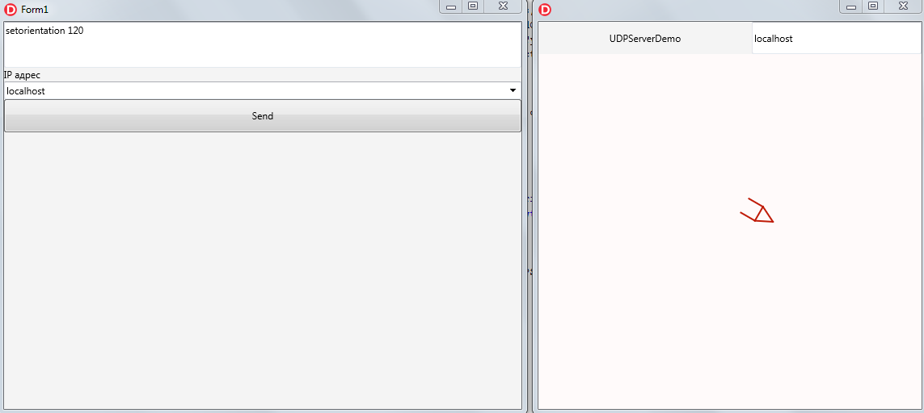

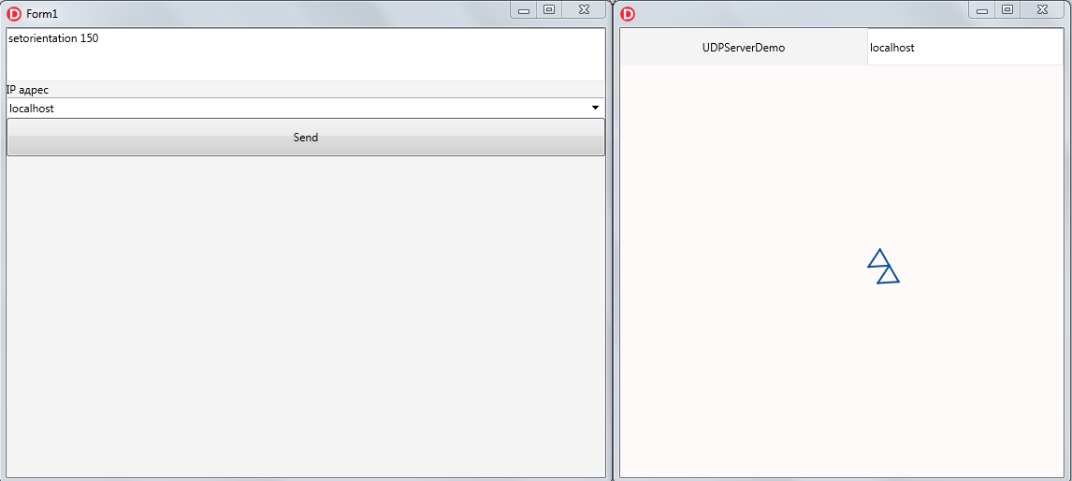

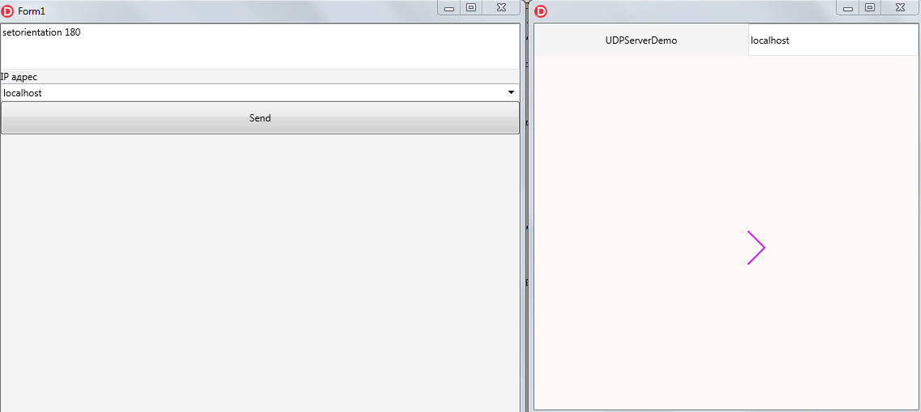

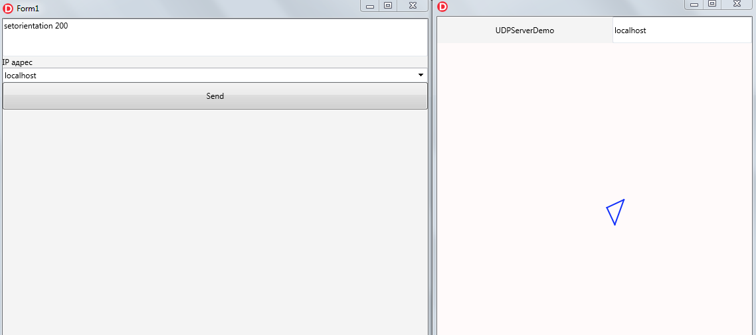

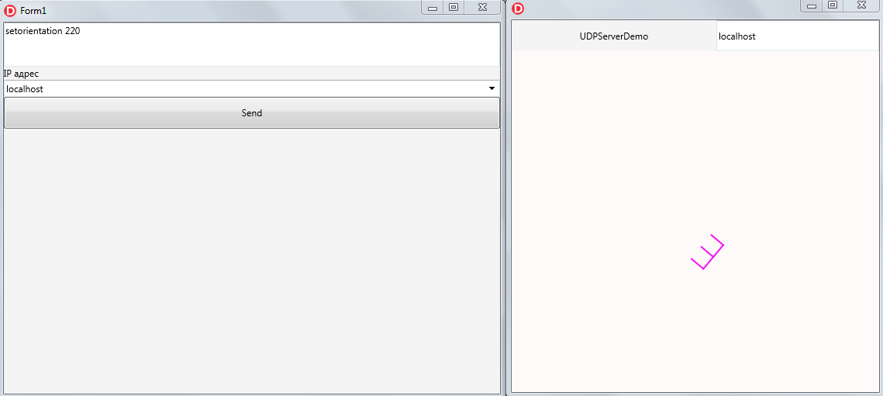

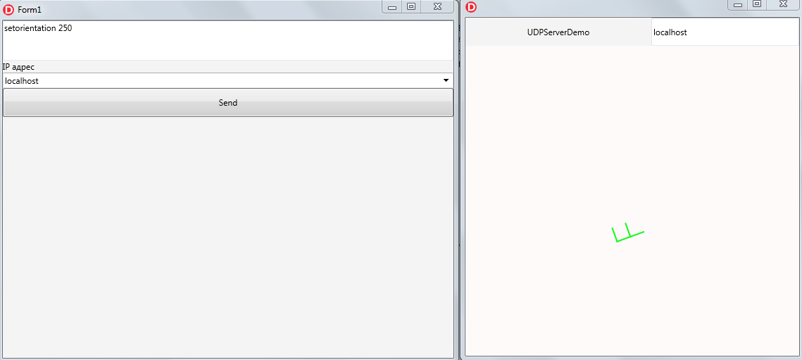

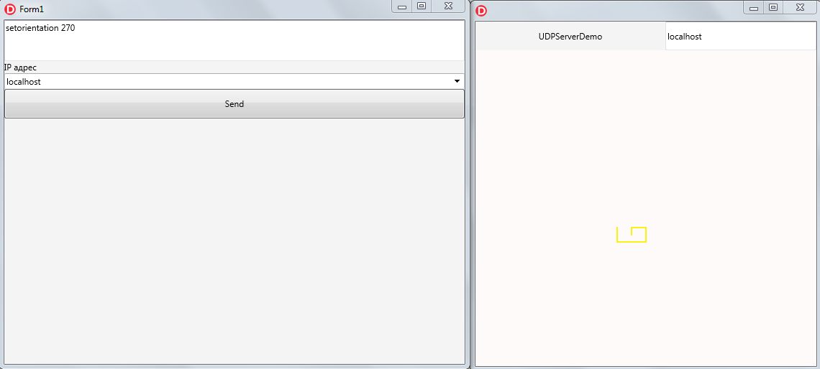

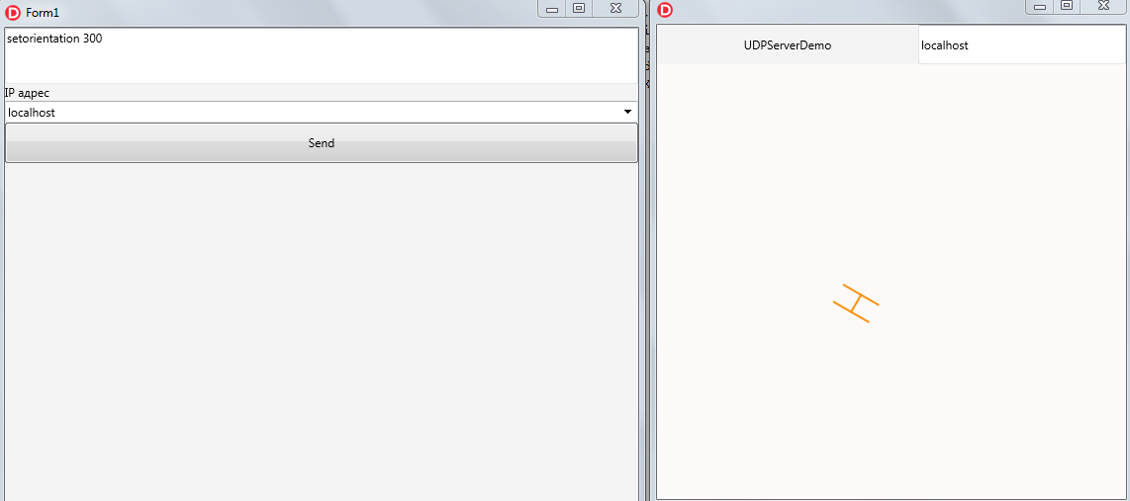

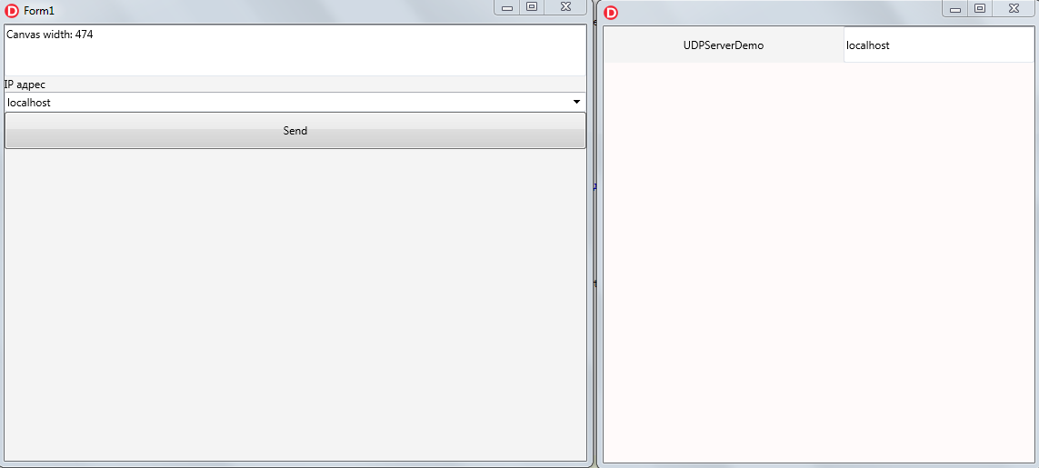

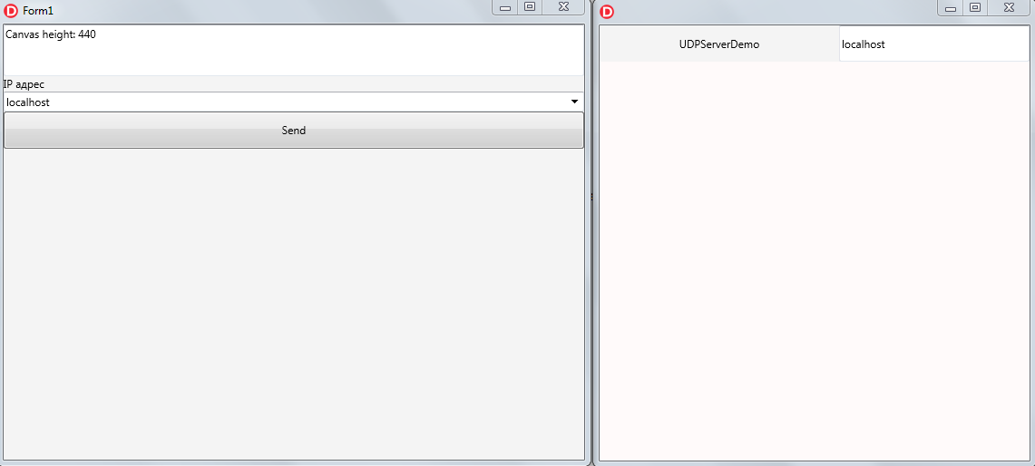

**Андроїд:**

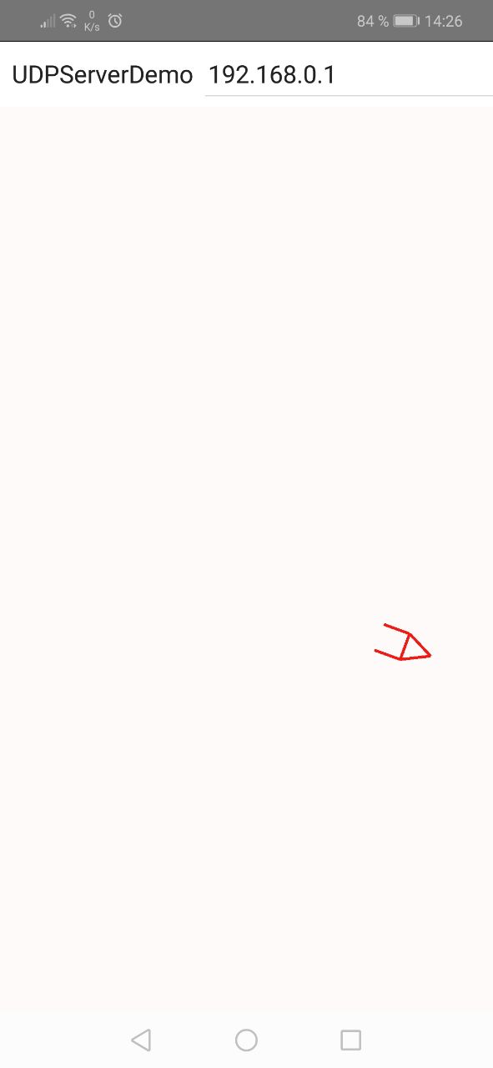

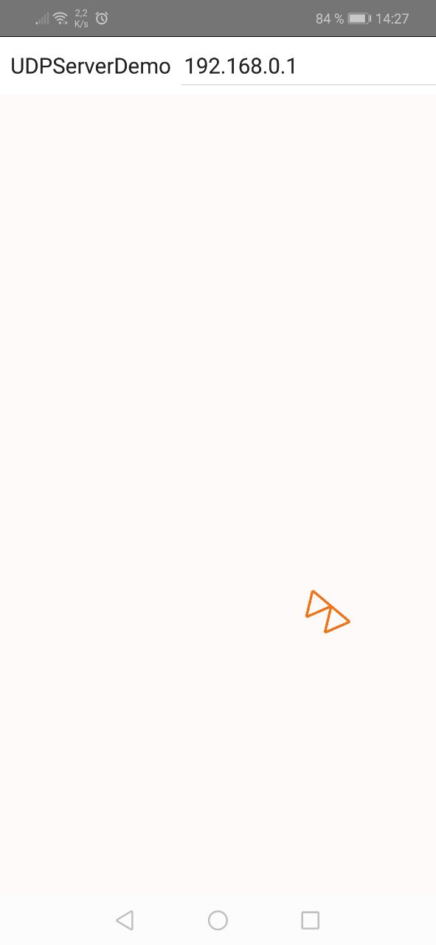

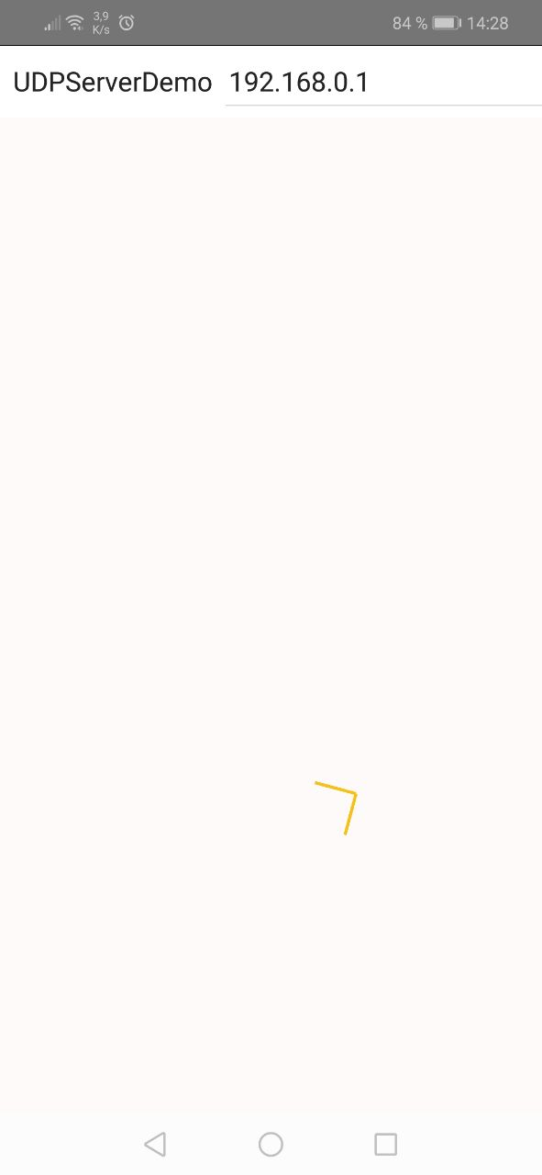

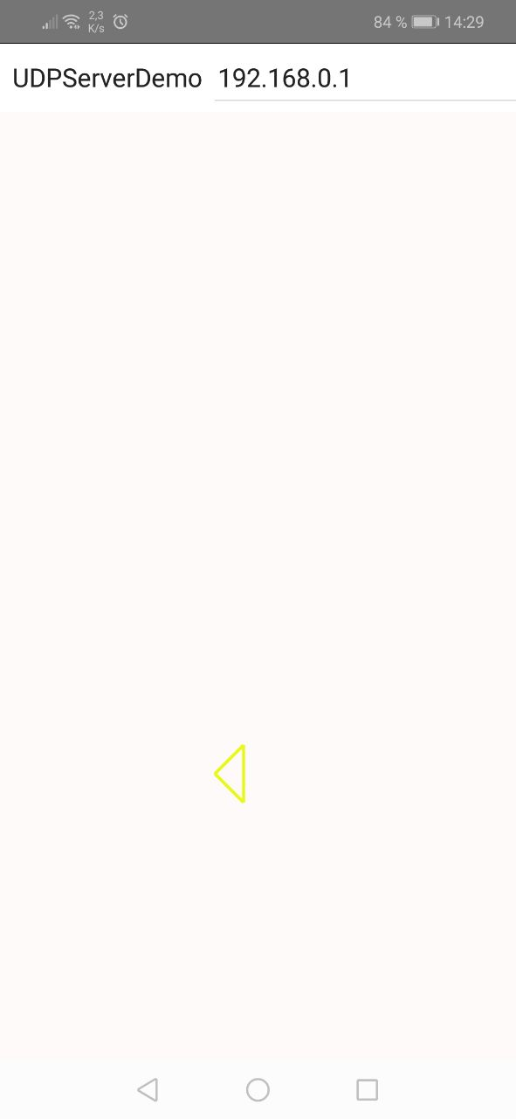

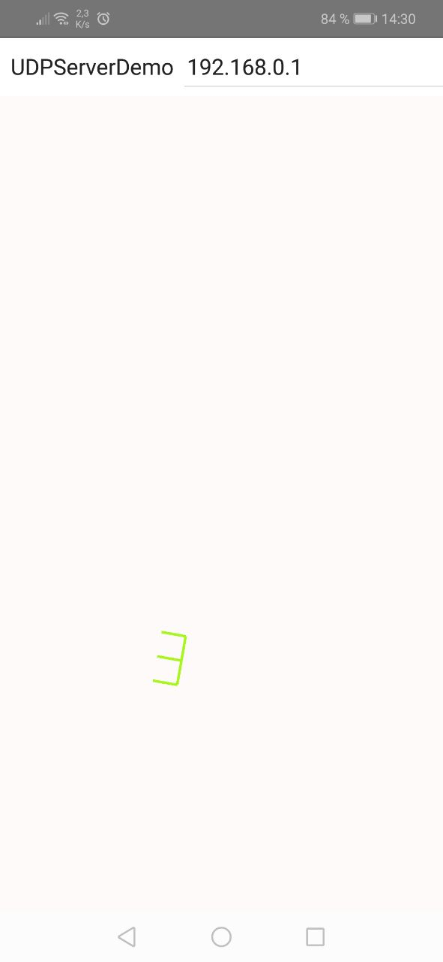

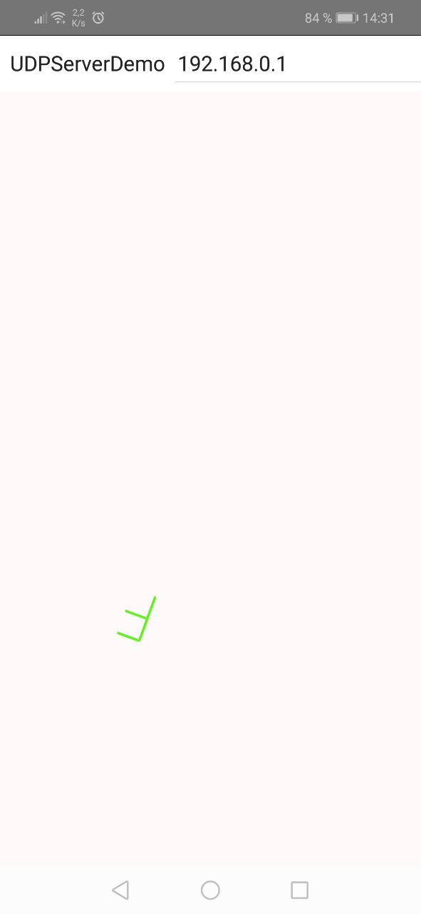

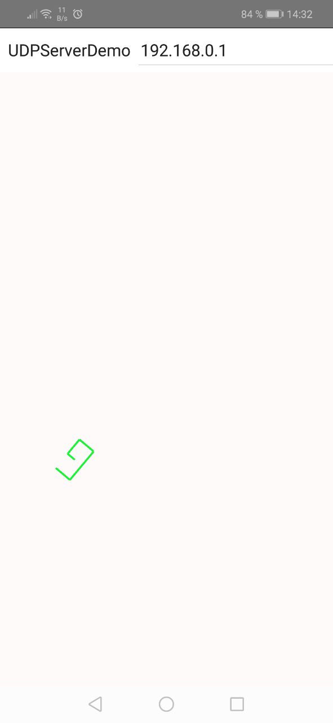

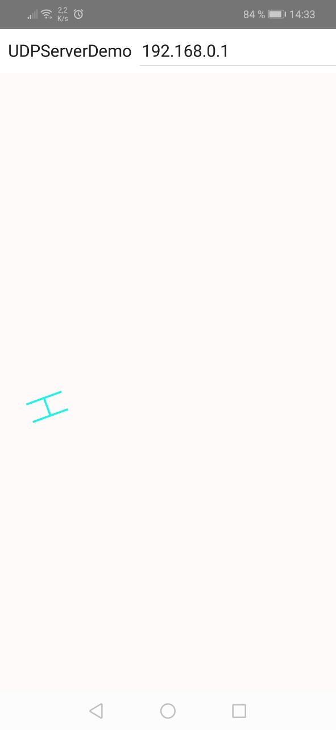

**Висновок:** Удосконалив програми емулятора дисплейного модуля і клієнта.